

The official bulletin of the District Grand Lodge of Carpentaria

Issue 69
68

March
2025

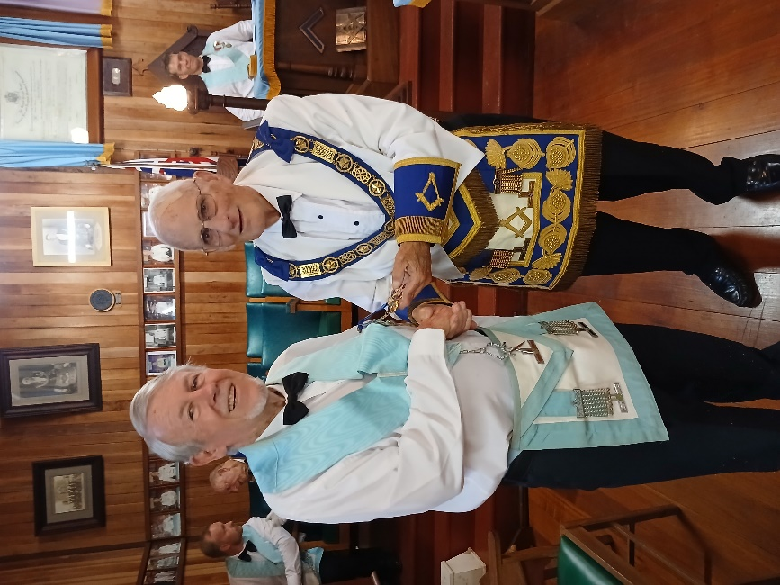
RW Bro Bob Wakeley presenting WBro Bruce Herriott PM with his 50-year jewel at the February meeting of Barrine Lodge.
Bruce started his Masonic Career as a young doctor joining in 1958 Knox Lodge 909 NSW. After moving to the sunshine state, he Joined Barrine Lodge in 1989 and Duyfken in 2002. Bruce has served in many offices as well as Master.
This amazing man could serve not only in a role as a Mason but also as a busy doctor including time with the Flying Doctors organization.
All his brothers in Barrine and other Lodges wish him for the future.

Herberton Corrie wishes to advise that they will conduct the Installation of Bro John Joseph van Verchel as Mastet of Herberton-Corrie Lodge. We will hold the ceremony in the Atherton Masonic Centre on Saturday 12th April 2025,with the Grand Lodge entering at 10.15am. Installation cards have been sent to all Lodges.

Why is the beehive symbol in some Masonic writing?
The Beehive is a masonic symbol, very often seen as clipart and on collages of masonic imagery.
The Beehive often brings to mind a well-organized group of insects working together for a common goal. The term generally associated with it is Industry. Not in the modern sense of massive machines working to stamp out multiple like items, but in the more ancient sense of a group of individuals working to create something.
To our ancient operative brothers who came from the guilds of the middle-ages, Industry in the old meaning was how things were accomplished without modern heavy machinery. Individuals were assigned specific tasks based on their skill level. Some simply carried stone or other materials. Often placing it in the care of their more experienced brothers who fashioned the proper piece for the structure. Others still put their skills to planning how the structure was put together. Assigning tasks to help complete the structure. No one group was the linchpin to the project or structure, yet all were critical to make the project a success.
Fast forward to the arrival of speculative masonry and you have a hive of a new kind. Still you have a structure requiring workers on all levels to make the hive (in this case hive is a synonym for lodge) function and be successful. More experienced brothers in the craft share their knowledge with newer "workers" in the hive. All the while realizing they have their own task in the hive. Each does their part to make the hive function properly. Working on projects to bring success to the endeavour and the lodge. There is also the leader of the hive, in the case of a Masonic lodge the Worshipful Master, who reads and creates the plans and guides the workers on all levels to a successful project.
Whether you are talking about our ancient operative brothers or the modern hive (lodge), the end goal is still the same. A group of individuals working together for a common goal, the success of any one individual is important since it helps the larger structure of the hive succeed. Even with the opportunity for individual success and growth we still see the need for the overall structure of the hive to succeed. The hive must succeed otherwise the individual accomplishment has a reduced meaning, possibly even making the individual success meaningless. The idea for the hive is to assemble those who can work together and agree on the common goal of the hive.
Through this concept of Industry, our ancient operative brothers were able to create grand cathedrals and other enduring structures. It is also how modern Freemasonry makes successful lodges, some enduring for hundreds of years.

Lodges meeting in March.
LODGE | DATE |  | TIME |  | WHERE |  | WORK
Bentley Park | 15th Mar |  | 2.00 pm |  | Edmonton
Endeavour | 15th Mar |  | 2.00 pm |  | Edmonton
Freshwater | 21 Mar |  | 7.30 pm |  | Freshwater
Gregory Allan | 17th Mar |  | 7.30 pm | Freshwater |  | General Business
Cairns Gelling | 11th Mar |  | 5.30 pm | Freshwater
Temple Memorial | 3rd Mar |  | 7.30 pm | Freshwater
Pyramid Highleigh | 5th Mar |  | 7.30 pm | Gordonvale
Johnstone R. H. | 8th Mar |  | 3.00 pm | Innisfail
Granite | 31st Mar |  | 10.30 am | Mareeba
Pt Douglas Mossman | 13th Mar |  | 7.00 pm | Mossman
Ravenshoe | 20th Mar |  | 6.oo pm | Ravenshoe
Herberton Corrie | 12th Mar |  | 10.15 am | Herberton |  | Installation Br John Van Aerchel
Tully---Tyson | 5th Mar |  | 7.00pm | Tully
Trinity Daylight | 3rd Mar |  | 9.30 am | Whitfield
Barrine | 8th Mar |  | 3,00 pm | Yungaburra
Duyfken | 18th Mar |  | 5.30 pm | Ask sec 0429349297

